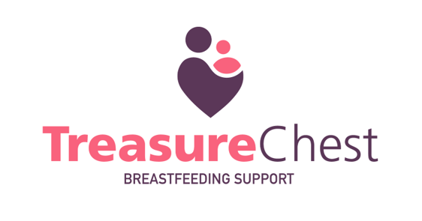
Organisations offering support

Support for postnatal depression and birth trauma

- PaNDAS (PND Awareness and Support)
Tel: 0808 1961 776
https://pandasfoundation.org.uk

- Birth Trauma Association
Supports parents suffering from postnatal Post Traumatic Stress Disorder (PTSD) or birth trauma.
www.birthtraumaassociation.org
The Birth Trauma Association Helpline: 0203 621 6338
Email: enquiries@birthtraumaassociation.org.uk

Counselling Services

- York Women’s Counselling
15 Priory Street, York YO1 6ET
Tel: 01904 652706
www.yorkwomenscounselling.org
Email: enquiries@yorkwomenscounselling.org

- Counselling Directory (Paid for, some with concession rates)
www.counselling-directory.org.uk/city/york

- 121 Counselling York (Free service)
https://121counsellingyork.org
Confidential answerphone: 07587 155678

- York & Selby Talking Therapies (NHS counselling referral service)
Self referral telephone number: 01904 556840
https://yorkandselbytalkingtherapies.co.uk

Mental health support

- Healthwatch York
https://www.healthwatchyork.co.uk/
Guide to Mental Health and Wellbeing in York:
https://www.healthwatchyork.co.uk/wp-content/uploads/2023/04/MHWguide_Final-draft_pr01-1.pdf

- Samaritans
Tel: 116 123 (free to call)
Tel: 0330 094 5717 (local call charges apply)
www.samaritans.org/branches/york/

- NHS - TEWV Crisis Service
Tel: 0800 0516 171 (24 hours, 7 days a week)
www.tewv.nhs.uk/crisisadvice

- MIND
Tel: 0300 123 3393
www.mind.org.uk
Email: info@mind.org.uk

- Calm (Campaign Against Living Miserably)
Tel: 0800 58 58 58 (5pm-midnight, 365 days/year)
www.thecalmzone.net

- Shout
24 hour text support on 85258
https://giveusashout.org/

- Mental Health Matters: The Haven @ 30 Clarence Street
Mon-Fri 6pm - 10pm and Sat-Sun 12pm - 10pm
Tel: 07483 141 310
www.mhm.org.uk/the-haven-30-clarence-street
Email: haven.mhm@nhs.net

Rights during pregnancy, birth and postnatally

- AIMS
Supports women and families to achieve the birth that they want.
Tel: 0300 365 0663
www.aims.org.uk
Email: helpline@aims.org.uk

- Birthrights
Maternity care advice and information service.
www.birthrights.org.uk
Advice request form: https://birthrights.org.uk/advice-factsheets/request-advice

Pregnancy termination, pregnancy and infant loss

- Reflect
Free support for anyone facing a pregnancy choice and support after pregnancy or neonatal loss.
Tel: 01904 676710; Text: 07517 624750
https://reflectyork.co.uk/
Email: enquiry@reflectyork.co.uk

- Sands
Provides bereavement support services.
Tel: 0808 164 3332
www.sands.org.uk/
Email: helpline@sands.org.uk

Domestic and sexual abuse support

- IDAS (Independent Domestic Abuse Services)
Tel: 03000 110 110 (North Yorkshire & Barnsley)
www.idas.org.uk
info@idas.org.uk

- Survive (York)
Support for male and female survivors of childhood sexual abuse, adult rape and sexual assault.
Tel: 01904 638813
www.survive-northyorks.org.uk
Email: survive@survive-northyorks.org.uk

Making a complaint about health care

- NHS Complaints Advocacy Service
www.voiceability.org/about-advocacy/types-of-advocacy/nhs-complaints-advocacy

- York PALS (Patient Advice and Liaison Service)
www.yorkhospitals.nhs.uk/contact-us/patient-experience/patient-advice-and-liaison-service-pals/

- Healthwatch York
https://www.healthwatchyork.co.uk/your-feedback/
Email: healthwatch@yorkcvs.org.uk

Welfare, family and employment rights

- Citizens Advice
Benefits advice and signposting to financial help for new parents.
Tel: 0808 278 7895
www.citizensadviceyork.org.uk/

- Family Rights Group – dealing with Social Services
Advises families about rights and options when social workers or courts make decisions about children’s welfare.
Tel: 0808 801 0366 (Mon–Fri, 9.30am–3pm)
https://frg.org.uk/
Email: office@frg.org.uk

- Maternity Action
Protects and supports the rights of pregnant women, new mothers and their families to employment, social security and health care.
Tel: 0808 802 0029 (Mon–Fri, 10am–1pm)
https://maternityaction.org.uk/

Others

- Kyra Women’s Project
Helps local women make positive change in their lives by offering courses, therapies, life skills and events.
Tel: 01904 632332
www.kyra.org.uk/
Email: contact@kyra.org.uk

- Homestart
Supports families in the York area to help parents give their children the best start in life.
Tel: 07519 976946
www.homestartyork.org/
Email: support@homestartyork.or

